LAB 2

1. Install VMware on the laptop.
2. Download ISO files of Windows 10 and Ubuntu 16.
3. Using VMWare, we create a virtual machine and install windows on to it by allocating some meory from the hard drive to it(60GB).

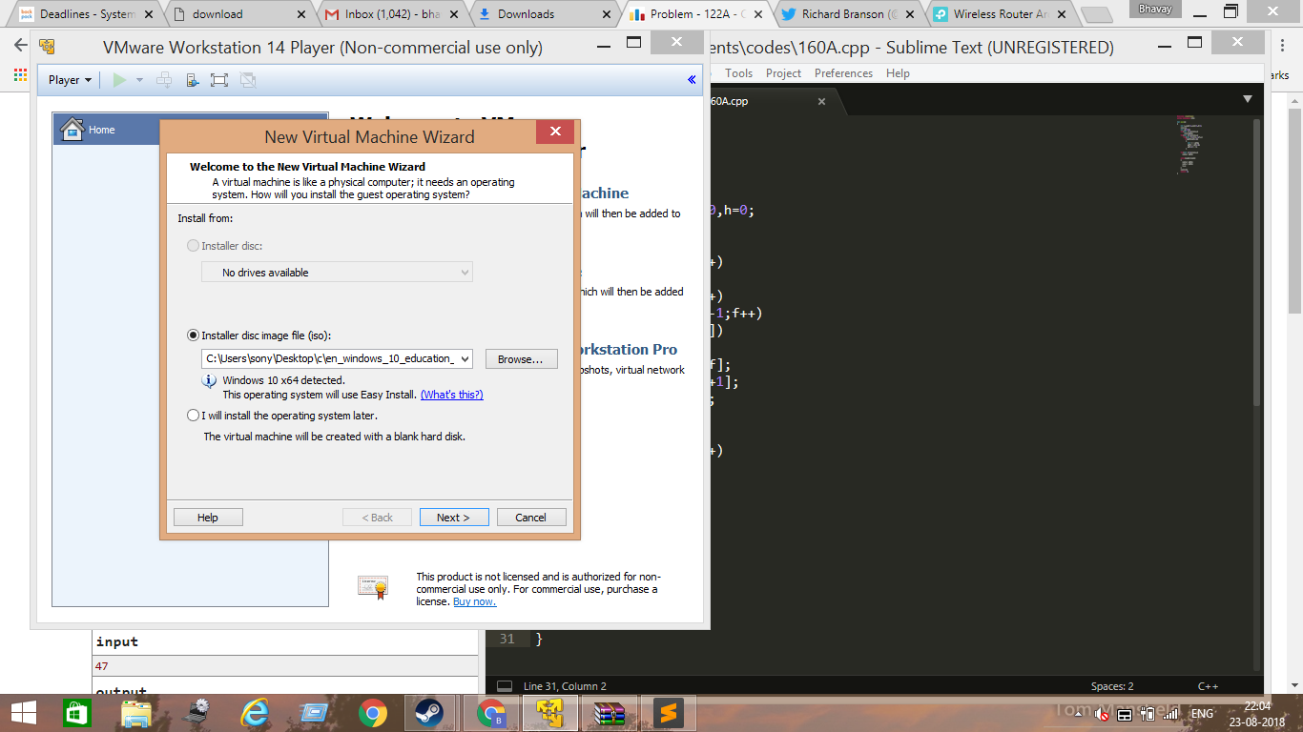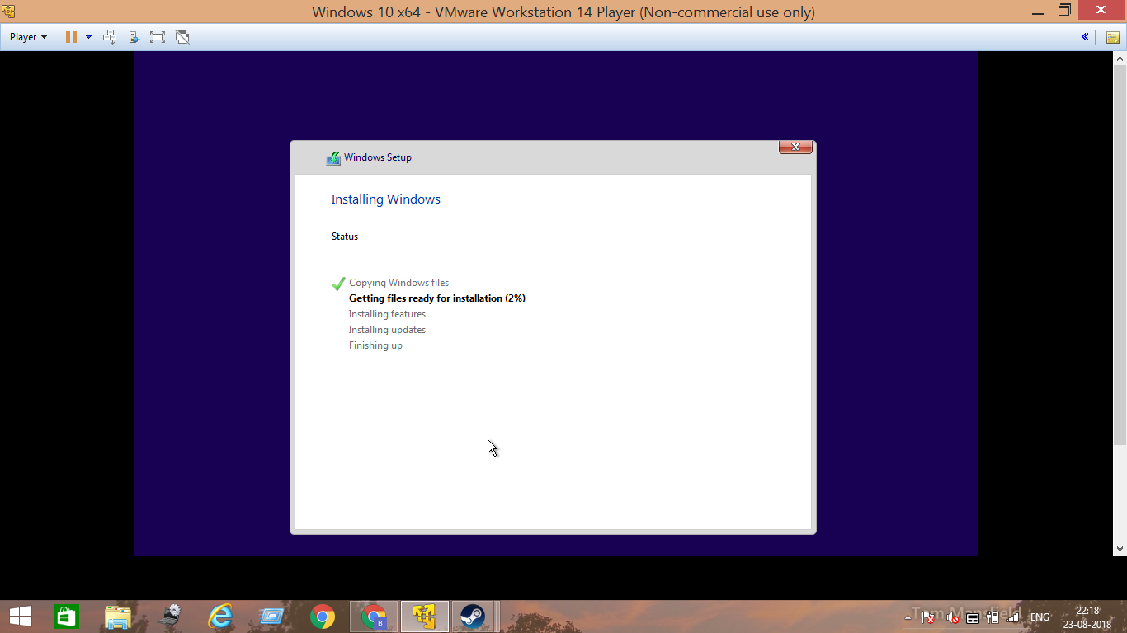

1. Now we shrink the size of the space allocated to the windows on the virtual machine to 30GB to create space for the Ubuntu. To do this, we access the disk management settings present in windows, select the drive we want to shrink and then select the amount to shrink.

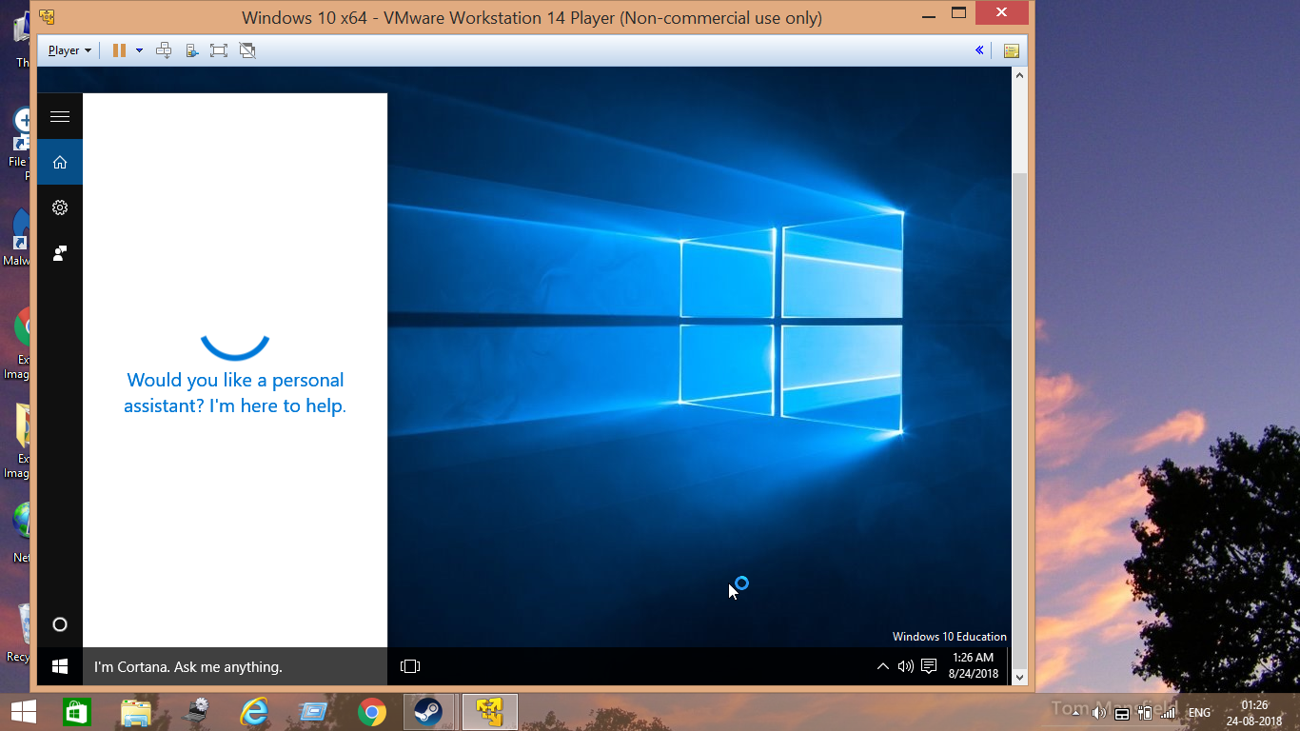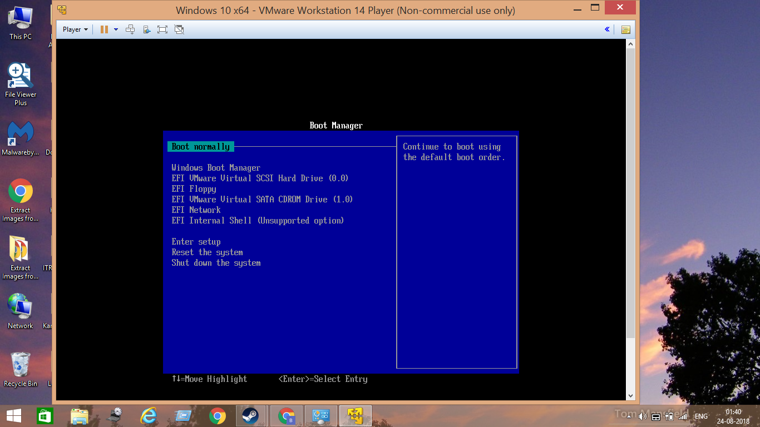

1. Then we boot Ubuntu to the CD-ROM of the virtual machine.

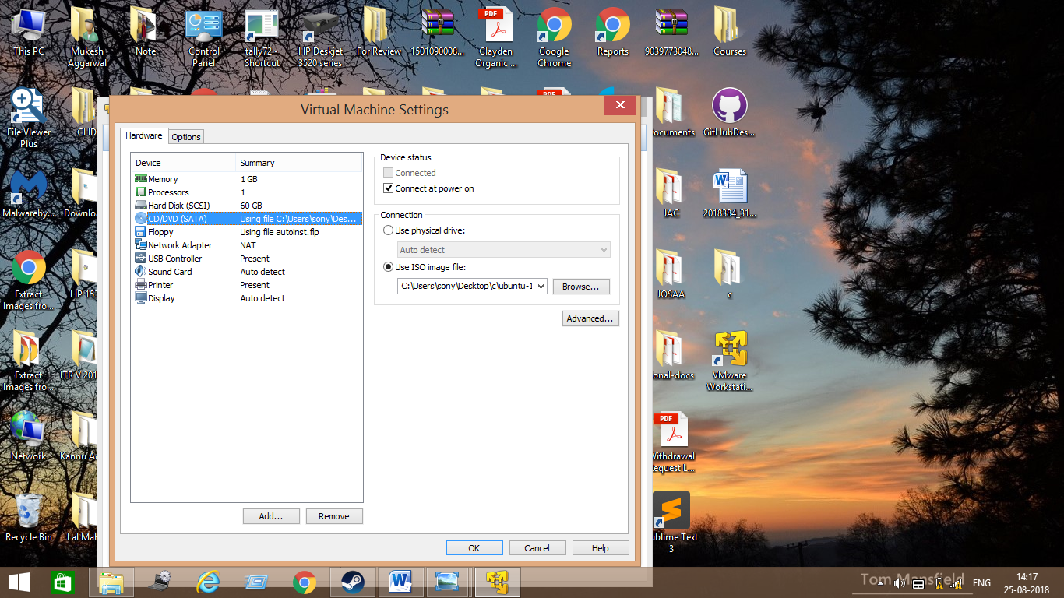

1. Now we enter the BIOS of the windows created on the virtual machine, and select the CD-ROM so that we can install the Ubuntu we just booted on it.



1. Now we install Ubuntu.

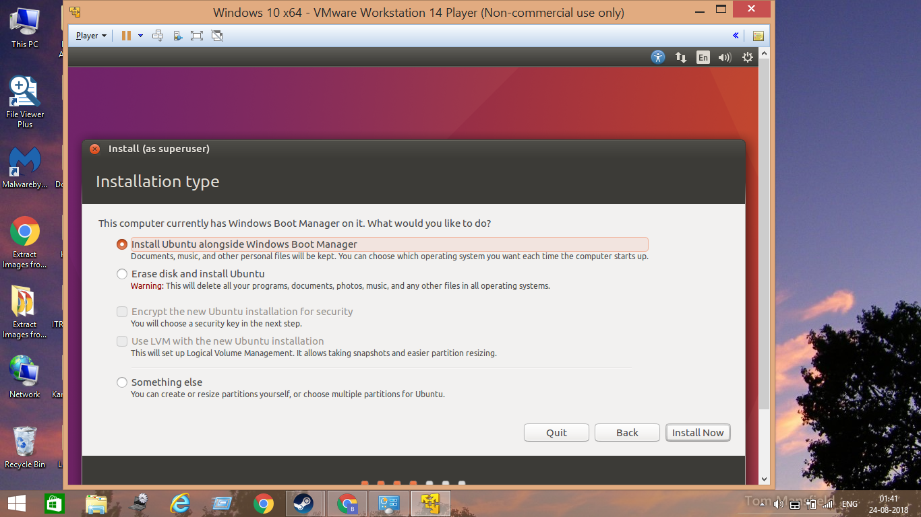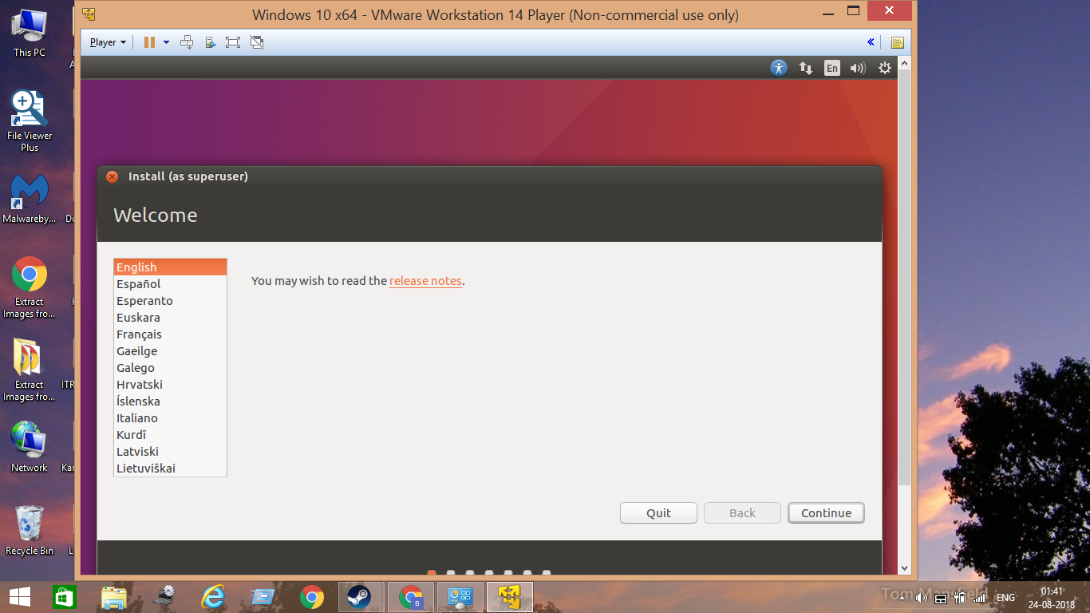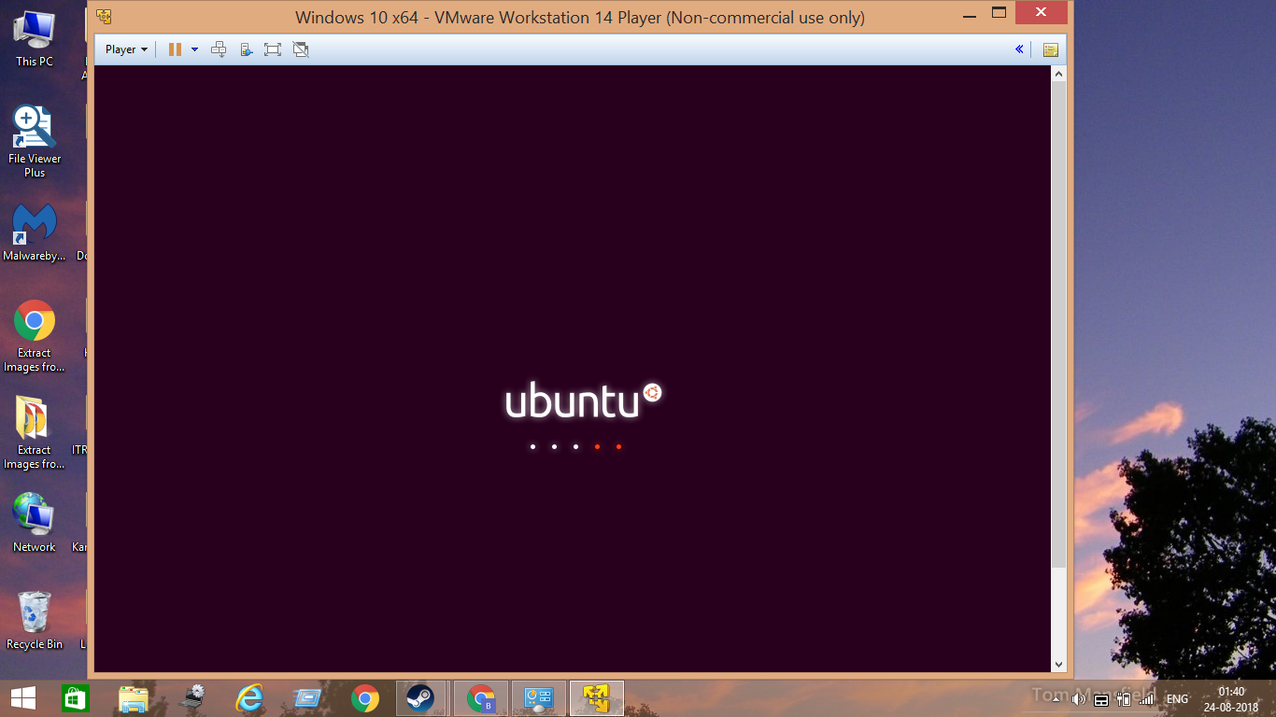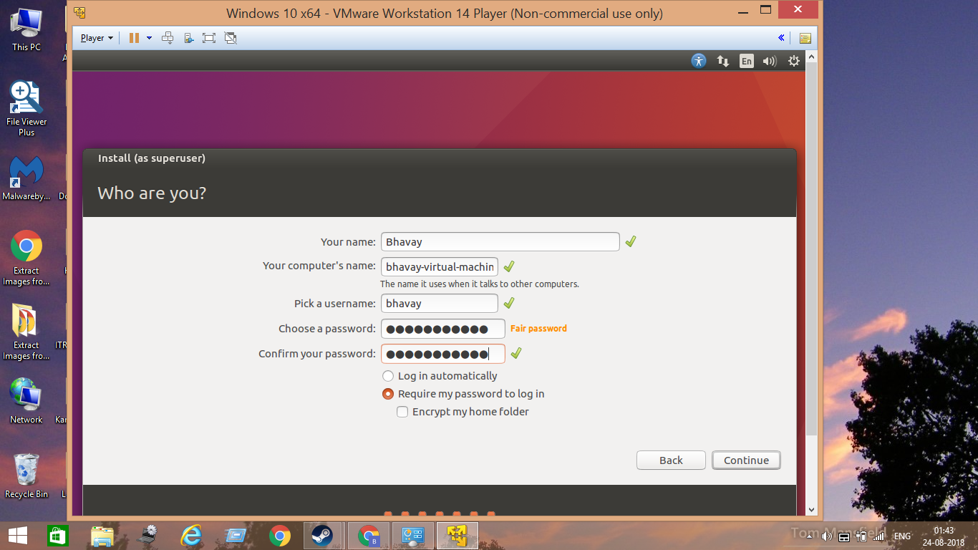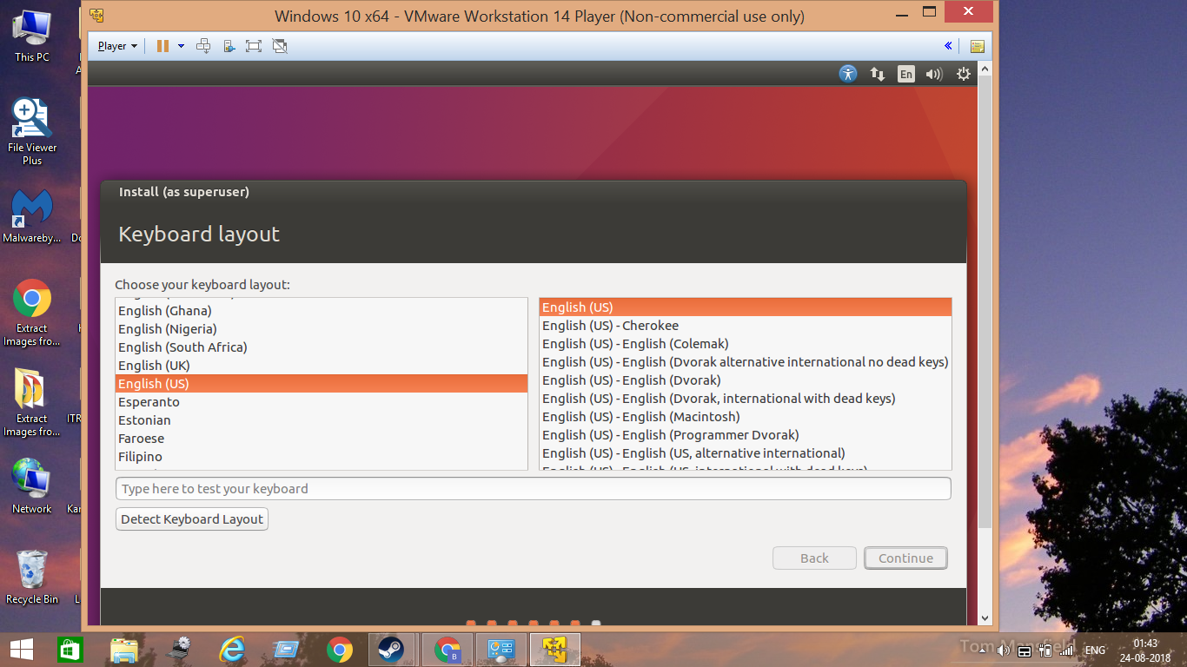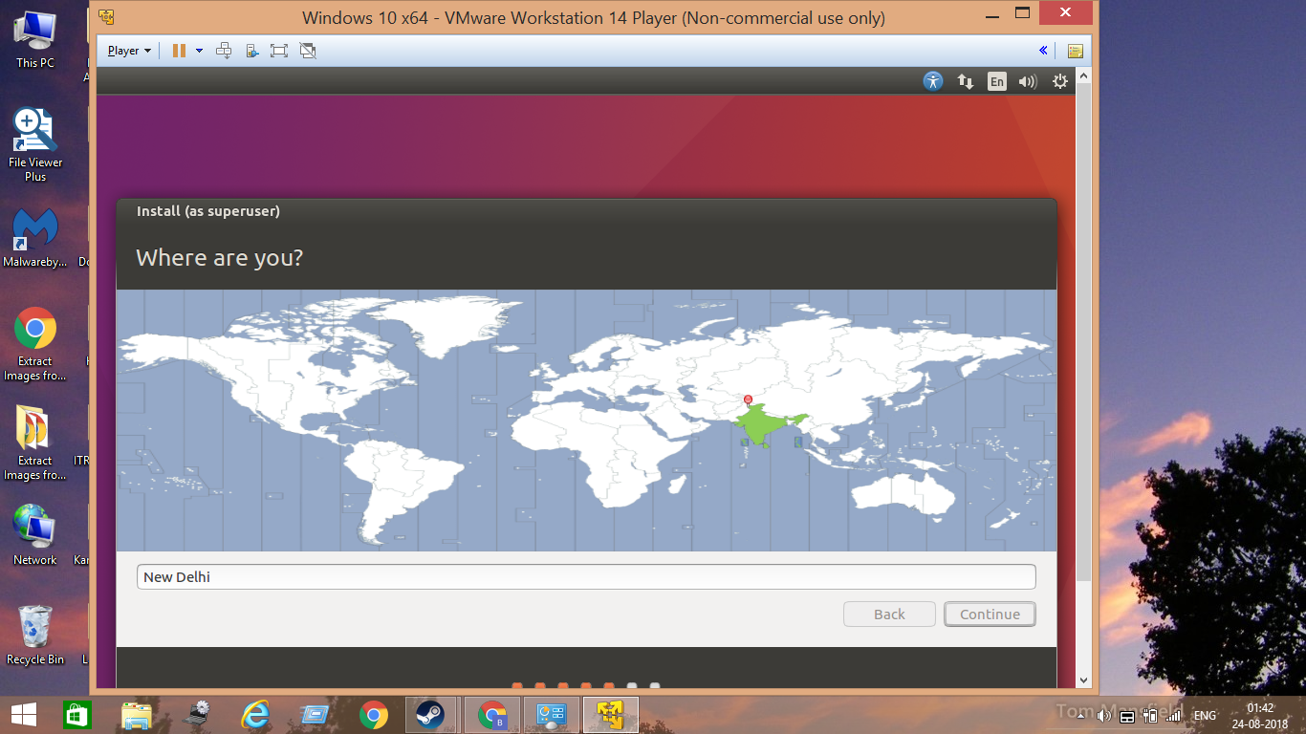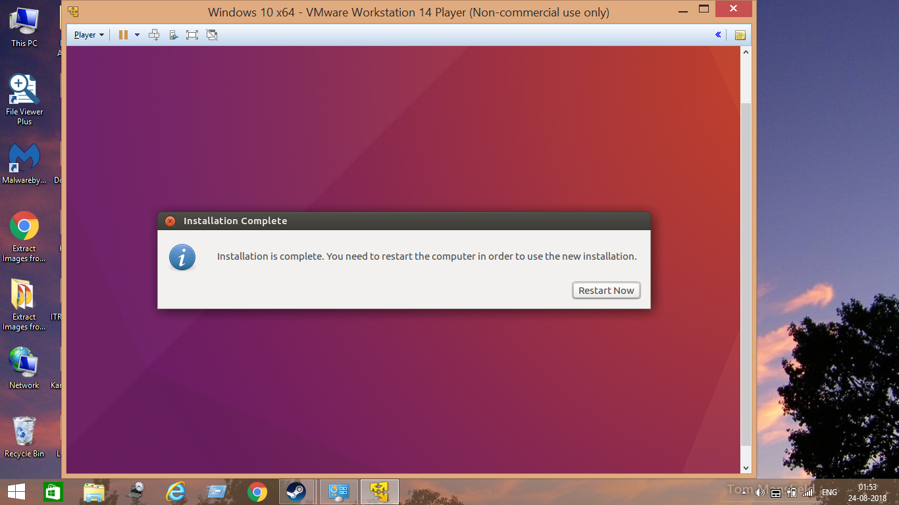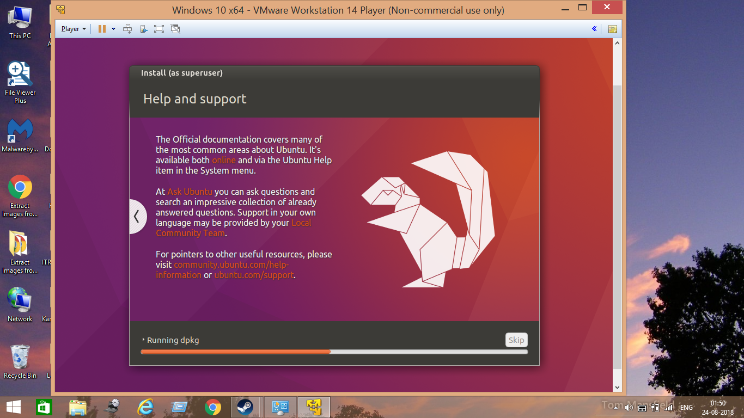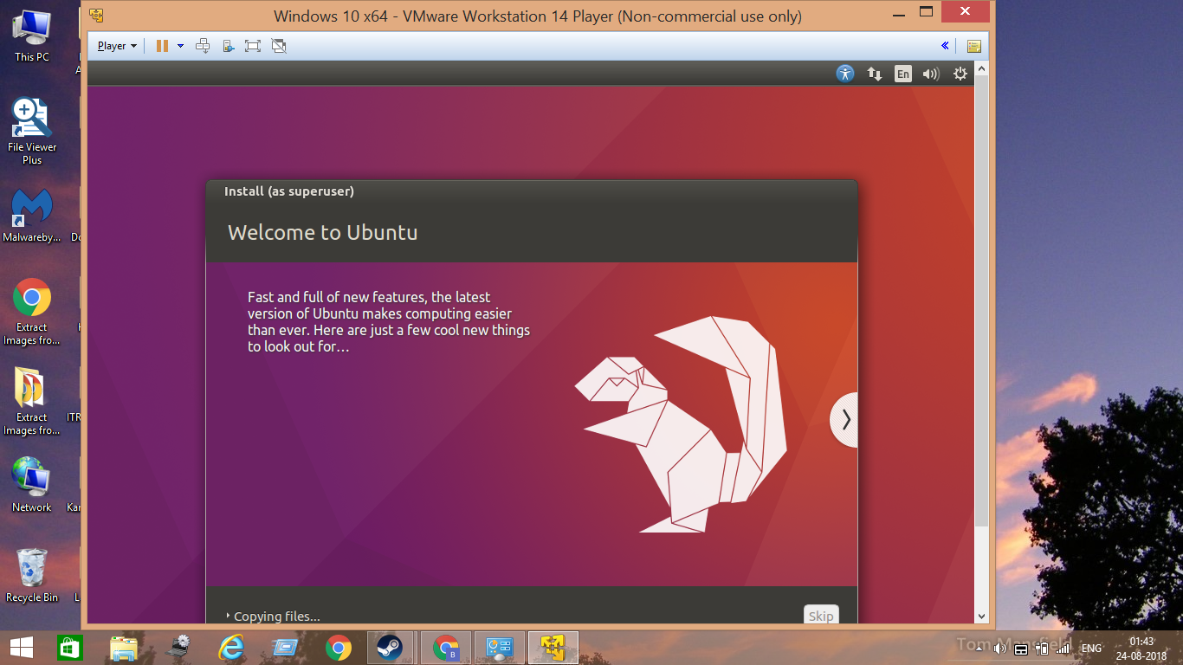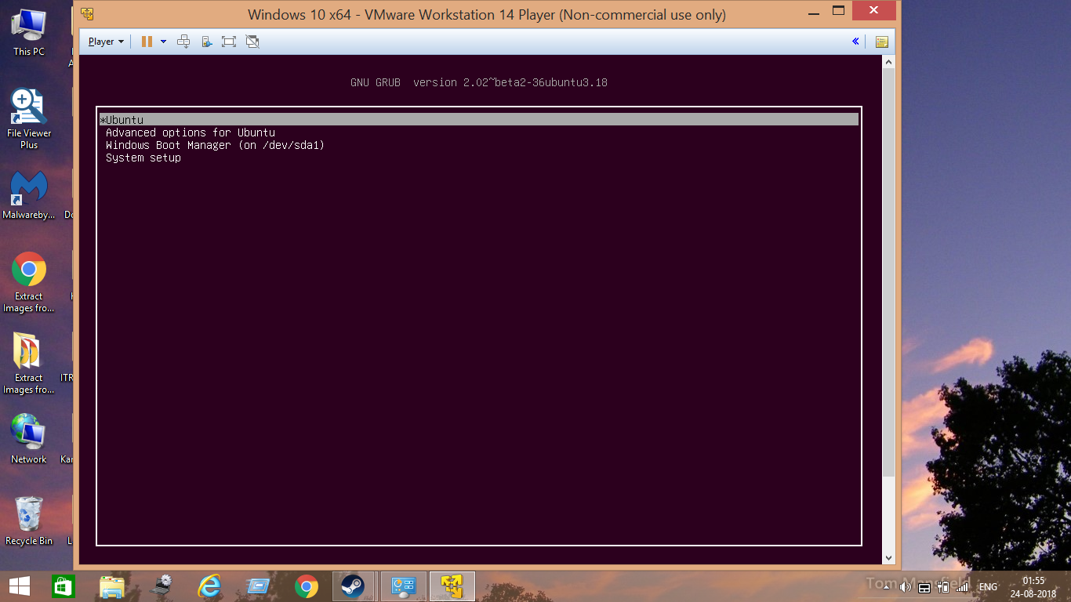

1. Ubuntu has been successfully installed and as we restart we see the GRUB menu which allows us to choose between windows and Ubuntu to boots up which means we have successfully partitioned the virtual machine!!!!

